Participation Workshop Resource Checklist
- Drinks: variety of hot and cold drinks and sugar, sweeteners, milk etc
- Food: snacks and/or lunch/dinner
- Utensils: plates, cups, serviettes, cutlery
- Box of chocolates/sweets for ending game/thank you
- Chunky Pens: Sharpies, flipchart pens, whiteboard markers
- Writing pens and pencils
- Post-it notes: Variety of colours, shapes, sizes
- Temporary wall adhesive: blue tac, white tac or masking tape
- Blank stickers for name badges
- Stickers for ranking/voting exercises: coloured dots or numbered stickers
- Flip chart paper: consider if access to flip chart stand is needed?
- Tech for presentations: laptop, projector, speaker, cables
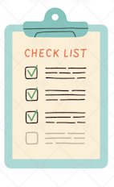
- Watch or a clock to keep time
- Games resources
- Spare project paperwork: information sheets, consent forms
- Petty cash
- Thank you cards
- Vouchers or other form or remuneration
- Follow up information sheet
- What else? ……………………………………………….
- ………………………………………………………………….
- ………………………………………………………………….
- ………………………………………………………………….
- ………………………………………………………………….
- ………………………………………………………………….
- ………………………………………………………………….

