**Example of Graphic Facilitation**

A process through which visual representations of emerging findings and the subsequent discussions about those findings enabled women’s and children’s involvement in analysis and the production of final outputs which were used to influence a national strategic funding review

**STEP 1:** A visual representation of the early analysis of findings was developed through a collaboration between the researcher and Graphic Facilitator. These images were shared during a workshop with women and children from the service that the research had been undertaken in. These images were then the focus for a ‘sense-checking’ discussion and annotated by participants (using post-it notes) which helped to further prioritise, nuance, amend and add to the findings. (Images and graphic facilitation by Claire Mills)

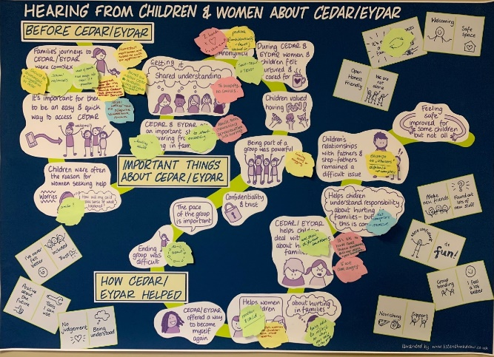

**NOTE:** references on image to ‘CEDAR’ and ‘EDYAR’ refer to a specialist domestic abuse programme from women and children

**STEP 2:** The images were then refined and revised by the graphic facilitator and two updated versions of the images (one for children and one for women) were used both for the research.

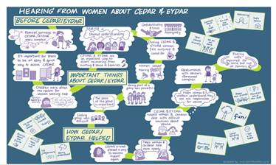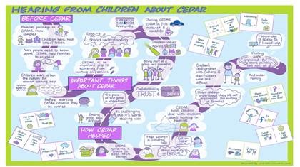

**STEP 3:** Images from step 2 were used as a tool to support participants (women and children) to share key messages from the research directly with the Chair of the [Independent Strategic Review of Funding and Commissioning of Violence Against Women and Girls (VAWG) Services](https://www.gov.scot/groups/violence-against-women-and-girls-strategic-review-of-funding-and-commissioning-of-services/) who visited the group. This discussion was then also illustrated (see below) and the images shared with the Strategic Review.

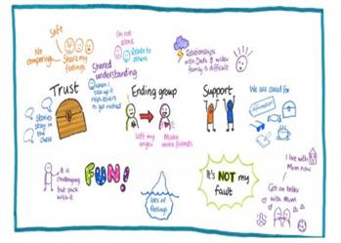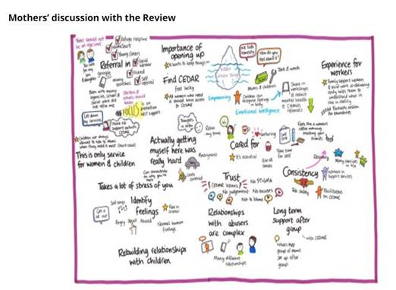

A final image, sharing key message from this series of workshops was included in the Strategic Review’s [report](https://www.gov.scot/binaries/content/documents/govscot/publications/independent-report/2023/06/violence-against-women-girls-independent-strategic-review-funding-commissioning-services-report/documents/independent-strategic-review-funding-commissioning-violence-against-women-girls-services/independent-strategic-review-funding-commissioning-violence-against-women-girls-services/govscot%3Adocument/independent-strategic-review-funding-commissioning-violence-against-women-girls-services.pdf).