Example Information Comic
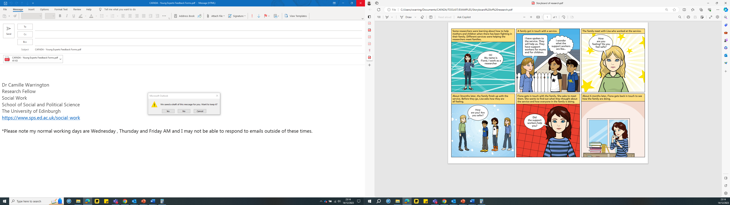
Fig X: Information Comic – explaining the research process. Created by Fiona Morrison for CAFADA Project, 2020

