Young Expert Group Example Timeline
Young expert group timeline for the first phase of CAFADA with a focus on information, approaches, data collection tools in particular outcome measures for safety and well-being.
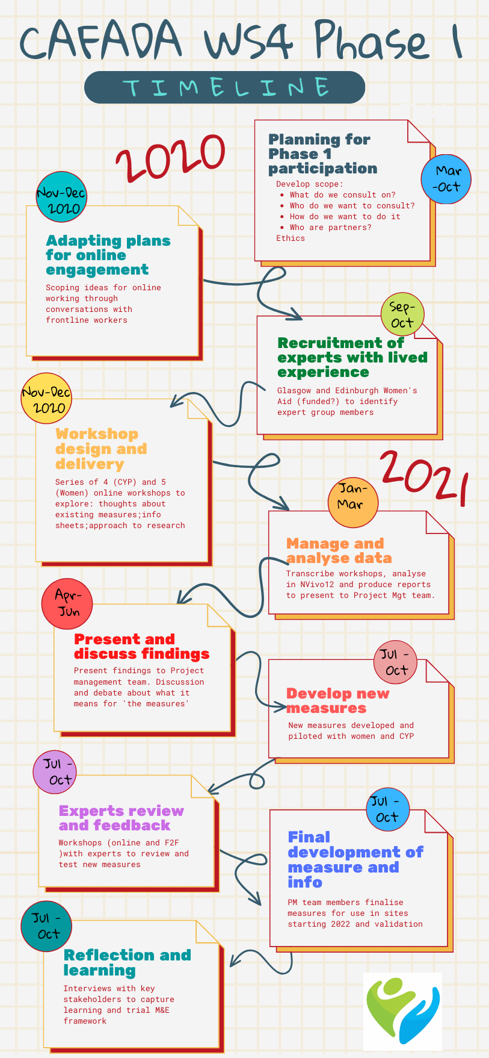
Planning (month 1- 3) Complete ethics application: develop scope/objectives and terms of reference for groups; identify and approach potential partners; explore different models with partners; plans shift from face to face to online.
Participation work adapted to online (month 4 – 5) Scoping chats to find out how different organisations experienced shifting participation work online. Capturing and sharing transferable learning.
Expert Advisor Recruitment (months 6 - 7) Four young experts recruited via agreed non-governmental organisation (NGO) partners – specialist domestic abuse services (all with experience of group or participation work).
Workshop Delivery (months 8 - 10) Online consultation groups designed and led by CAFADA researchers with support from NGO staff.
Focus on participant info about CAFADA; feedback on existing data collection tools (outcome measures); an approach to research involvement and identifying relevant indicators of safety and wellbeing/ resilience after domestic abuse
Analyse workshop data (months 11 - 12) All data (transcripts, screen shots and worksheets) coded and analysed thematically. Two reports/presentation finalised.
Discuss findings (months 13) Findings of workshop analysis presented to project management group for feedback
Draft new research tools (months 13 - 14) Researchers review findings and discuss with research management group - used as basis for developing new data collection tools with further expert group input.
Experts Advisor Review Feedback reports shared with all experts. Return to experts to ‘test’ and review new data collection tools through online and face to face workshops with young experts
Final stage one measures development (Oct – Dec 21) Final revised outcome measures updated by wider CAFADA team and ready for piloting/use (See measures).
Reflection and learning (Oct – Nov 21) Interviews with key stakeholders to capture learning about the process – using our participatory monitoring and evaluation framework at same time.

