**Young Expert Group Example Timeline**

**Young expert group timeline for the first phase of CAFADA with a focus on information, approaches, data collection tools in particular outcome measures for safety and well-being.**

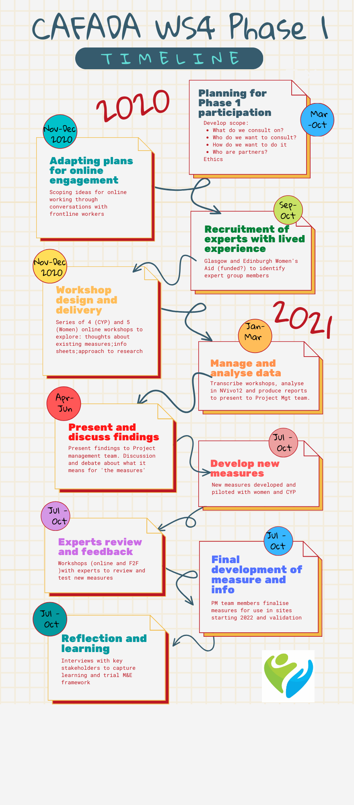**Planning** *(month 1- 3)* Complete ethics application: develop scope/objectives and terms of reference for groups; identify and approach potential partners; explore different models with partners; plans shift from face to face to online.

**Participation work adapted to online** *(month 4 – 5)* Scoping chats to find out how different organisations experienced shifting participation work online. Capturing and sharing transferable learning.

**Expert Advisor Recruitment** *(months 6 - 7)* Four young experts recruited via agreed non-governmental organisation (NGO) partners – specialist domestic abuse services (all with experience of group or participation work).

**Workshop Delivery** *(months 8 - 10)* Online consultation groups designed and led by CAFADA researchers with support from NGO staff.

Focus on participant info about CAFADA; feedback on existing data collection tools (outcome measures); an approach to research involvement and identifying relevant indicators of safety and wellbeing/ resilience after domestic abuse

**Analyse workshop data** *(months 11 - 12)* All data (transcripts, screen shots and worksheets) coded and analysed thematically. Two reports/presentation finalised.

**Discuss findings** *(months 13)* Findings of workshop analysis presented to project management group for feedback

**Draft new research tools** *(months 13 - 14)* Researchers review findings and discuss with research management group - used as basis for developing new data collection tools with further expert group input.

**Experts Advisor Review** Feedback reports shared with all experts. Return to experts to ‘test’ and review new data collection tools through online and face to face workshops with young experts

**Final stage one measures development** *(Oct – Dec 21)*Final revised outcome measures updated by wider CAFADA teamand ready for piloting/use (See measures).

**Reflection and learning** *(Oct – Nov 21)* Interviews with key stakeholders to capture learning about the process – using our participatory monitoring and evaluation framework at same time.